Ex No : 3 Design the front-end part of the application using

Angular Js and React JS

Aim

1.Include the following Features of AngularJS to build a web application for your chosen idea Filters
  - Dependency Injection
  - Services
  - factories
  - Directives
  - Modules
  - Filters
  - Animations

Application : BookNGo

Description :
An all-in-one travel , tour , room booking and tour management system which provides an one stop solution to all needed services for a tour.

Pages:

1. Tour Package Booking Page

  - Allows users to select travel date, time, and the number of tickets (adult, youth, child).
  - Users can also add extra services like meal or guide.
  - AngularJS updates the total price instantly using two-way binding and change detection.
2. Transport Searching Page
  - Users enter the starting and destination locations.
  - Clicking the Search button displays available buses with departure times.
  - AngularJS uses model binding and dynamic list rendering to show filtered transport options.
3. Room/Home Booking Page
  - Users search for rooms based on location and travel date.
  - Matching rooms with details (images, ratings, price) are shown.
  - AngularJS filters and updates the view in real time as the user types or changes search input.

Code:
html/tourbook.js
<!DOCTYPE html>
<html ng-app="travelApp">
<head>
<meta charset="UTF-8">
<title>Tour Booking</title>
<link rel="stylesheet" href="../css/tourbook.css">
<script src="https://ajax.googleapis.com/ajax/libs/angularjs/1.8.2/angular.min.js"></script>
<script src="../js/tourbook.js"></script>
</head>
<body ng-controller="BookingController as bookCtrl">

<header class="header">
<h1>BookNGo</h1>
<nav>
<a href="#">Home</a>
<a href="#">Bookings</a>
<a href="#">Tours</a>
<a href="#">Contact</a>
</nav>
</header>

<section class="tour-info">
<h2>{{ bookCtrl.tour.name }}</h2>
<p><strong>Location:</strong> {{ bookCtrl.tour.location }}</p>
<p>{{ bookCtrl.tour.description }}</p>
</section>

<div class="booking-form">
<h2>Book Your Tour</h2>

<label>Date:</label>
<input type="date" ng-model="bookCtrl.booking.date"><br>

<label>Time:</label>
<input type="time" ng-model="bookCtrl.booking.time"><br>

<label>Adults:</label>
<input type="number" ng-model="bookCtrl.booking.adults" ng-change="bookCtrl.updateTotal()"><br>

<label>Youth:</label>
<input type="number" ng-model="bookCtrl.booking.youth" ng-change="bookCtrl.updateTotal()"><br>

<label>Children:</label>
<input type="number" ng-model="bookCtrl.booking.children" ng-change="bookCtrl.updateTotal()"><br>

<h3>Extras</h3>
<label><input type="checkbox" ng-model="bookCtrl.booking.meal" ng-change="bookCtrl.updateTotal()"> Add Meal (+₹100)</label><br>
<label><input type="checkbox" ng-model="bookCtrl.booking.guide" ng-change="bookCtrl.updateTotal()"> Add Guide (+₹200)</label><br>
<price-box price="bookCtrl.total"></price-box>

</div>

</body>
</html>

js/tourbook.js

angular.module('travelApp', [])
.controller('BookingController', ['BookingService', function(BookingService) {
var vm = this;
vm.tour = {
name: "Taj Mahal Sunrise Tour",
location: "Agra, Uttar Pradesh",
description: "Experience the majestic beauty of the Taj Mahal at sunrise with our guided tour including optional meals and expert commentary."
};
vm.booking = {
adults: 0,
youth: 0,
children: 0,
meal: false,
guide: false
};
vm.total = 0;
vm.updateTotal = function() {
vm.total = BookingService.calculateTotal(vm.booking);
};
}])
.factory('BookingService', function() {
return {
calculateTotal: function(booking) {
let total = (booking.adults * 500) + (booking.youth * 300) + (booking.children * 150);
if (booking.meal) {
total += 100 * (booking.adults + booking.youth + booking.children);
}
if (booking.guide) {
total += 200;
}
return total;
}
};
})

.directive('priceBox', function() {
return {
restrict: 'E',
scope: {
price: '='
},
template: '<div class="price-box">Total Price: ₹{{ price }}</div>'
};
});

html/transport.html

<!DOCTYPE html>
<html ng-app="travelApp">
<head>
<meta charset="UTF-8">
<title>Transport Search</title>
<link rel="stylesheet" href="../css/transport.css">
</head>
<body ng-controller="TransportController as vm">

<header>
<h1>BookNGo</h1>
<nav>
<a href="tourbook.html">Tour Info</a>
<a href="booking.html">Booking</a>
<a href="transport.html" class="active">Transport</a>
</nav>
</header>

<div class="search-container">
<label>From: <input type="text" ng-model="vm.search.from" placeholder="Origin"></label>
<label>To: <input type="text" ng-model="vm.search.to" placeholder="Destination"></label>
<label>Date: <input type="date" ng-model="vm.search.date"></label>
<label>Filter by Type:
<select ng-model="vm.filterType">
<option value="">All</option>
<option value="bus">Bus</option>
<option value="train">Train</option>
</select>
</label>
<button ng-click="vm.findTransport()">Search</button>
</div>

<div class="results">
<transport-card ng-repeat="t in vm.results | typeFilter:vm.filterType" data="t"></transport-card>
</div>

<script src="https://ajax.googleapis.com/ajax/libs/angularjs/1.8.3/angular.min.js"></script>
<script src="../js/transport.js"></script>
</body>
</html>

js/transport.js

angular.module('travelApp')
.controller('TransportController', ['TransportService', function(TransportService) {
var vm = this;

vm.search = {
from: '',
to: '',
date: ''
};

vm.filterType = '';
vm.results = [];

vm.findTransport = function() {
vm.results = TransportService.search(vm.search);
};
}])

.factory('TransportService', function() {
var data = [
{ from: 'Chennai', to: 'Agra', date: '2025-07-25', type: 'train', price: 1200 },
{ from: 'Chennai', to: 'Agra', date: '2025-07-25', type: 'bus', price: 800 },
{ from: 'Delhi', to: 'Agra', date: '2025-07-25', type: 'train', price: 700 },
{ from: 'Delhi', to: 'Agra', date: '2025-07-25', type: 'bus', price: 500 }
];

return {
search: function(criteria) {
return data.filter(d =>
(!criteria.from || d.from.toLowerCase() === criteria.from.toLowerCase()) &&
(!criteria.to || d.to.toLowerCase() === criteria.to.toLowerCase()) &&
(!criteria.date || d.date === criteria.date)
);
}
};
})

.directive('transportCard', function() {
return {
restrict: 'E',
scope: {
data: '='
},
template: `
<div class="card">
<h3>{{ data.type | uppercase }} - ₹{{ data.price }}</h3>
<p>{{ data.from }} ➡️ {{ data.to }}</p>
<p>Date: {{ data.date }}</p>
</div>
`
};
})

.filter('typeFilter', function() {
return function(items, type) {
if (!type) return items;
return items.filter(item => item.type === type);
};
});

html/booking.html
<!DOCTYPE html>
<html ng-app="travelApp">
<head>
<meta charset="UTF-8">
<title>Hotel Booking</title>
<link rel="stylesheet" href="../css/booking.css">
</head>
<body ng-controller="HotelController as vm">

<header>
<h1>BookNGo</h1>
<nav>
<a href="tourbook.html">Tour Info</a>
<a href="booking.html" class="active">Booking</a>
<a href="transport.html">Transport</a>
</nav>
</header>

<div class="hotel-search">
<input type="text" ng-model="vm.search.city" placeholder="Enter City">
<input type="date" ng-model="vm.search.date">
<select ng-model="vm.starFilter">
<option value="">All Stars</option>
<option value="5">5 Star</option>
<option value="4">4 Star</option>
<option value="3">3 Star</option>
</select>
<button ng-click="vm.findHotels()">Search</button>
</div>

<div class="hotel-results">
<hotel-card
ng-repeat="h in vm.hotels | starFilter:vm.starFilter"
data="h">
</hotel-card>
</div>

<script src="https://ajax.googleapis.com/ajax/libs/angularjs/1.8.3/angular.min.js"></script>
<script src="../js/booking.js"></script>
</body>
</html>

js/booking.js
angular.module('travelApp', [])
.controller('HotelController', function(HotelService) {
var vm = this;

vm.search = { city: '', date: '', stars: '' };
vm.starFilter = '';
vm.hotels = [];

vm.findHotels = function() {
vm.hotels = HotelService.getHotels(vm.search.city);
};
})

.factory('HotelService', function() {
const hotels = [
{ name: "The Oberoi", city: "Agra", stars: 5, price: 8000 },
{ name: "Hotel Taj Inn", city: "Agra", stars: 3, price: 2500 },
{ name: "Trident", city: "Jaipur", stars: 4, price: 4000 },
{ name: "Rambagh Palace", city: "Jaipur", stars: 5, price: 12000 }
];

return {
getHotels: function(city) {
return hotels.filter(h => h.city.toLowerCase().includes(city.toLowerCase()));
}
};
})

.filter('starFilter', function() {
return function(hotels, selectedStar) {
if (!selectedStar) return hotels;
return hotels.filter(h => h.stars == selectedStar);
};
})

.directive('hotelCard', function() {
return {
restrict: 'E',
scope: { data: '=' },
template: `
<div class="hotel-card">
<h3>{{ data.name }}</h3>
<p>City: {{ data.city }}</p>
<p>Stars: {{ data.stars }}</p>
<p>Price: ₹{{ data.price }}/night</p>
</div>
`
};
});

Screenshots:

Tour Booking:
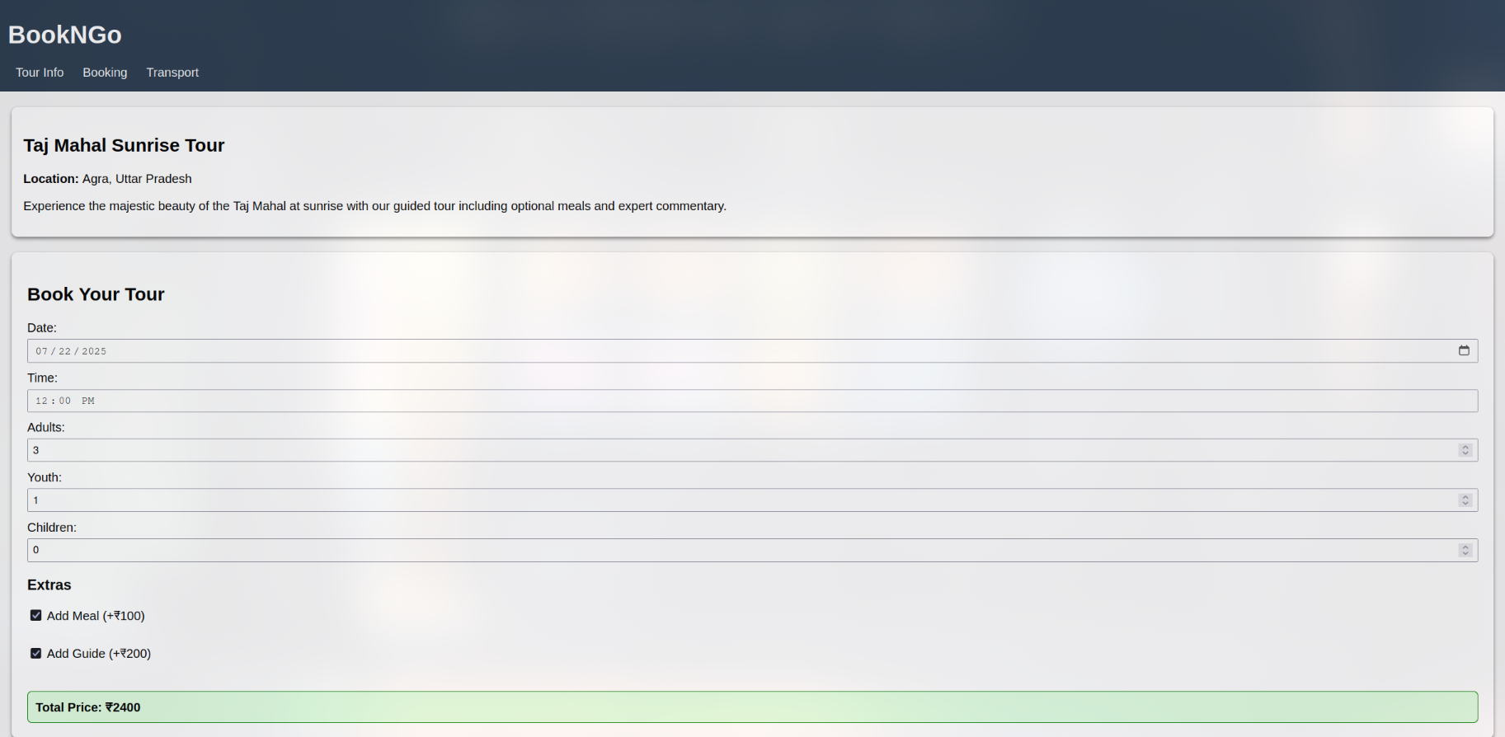
Transport Page:
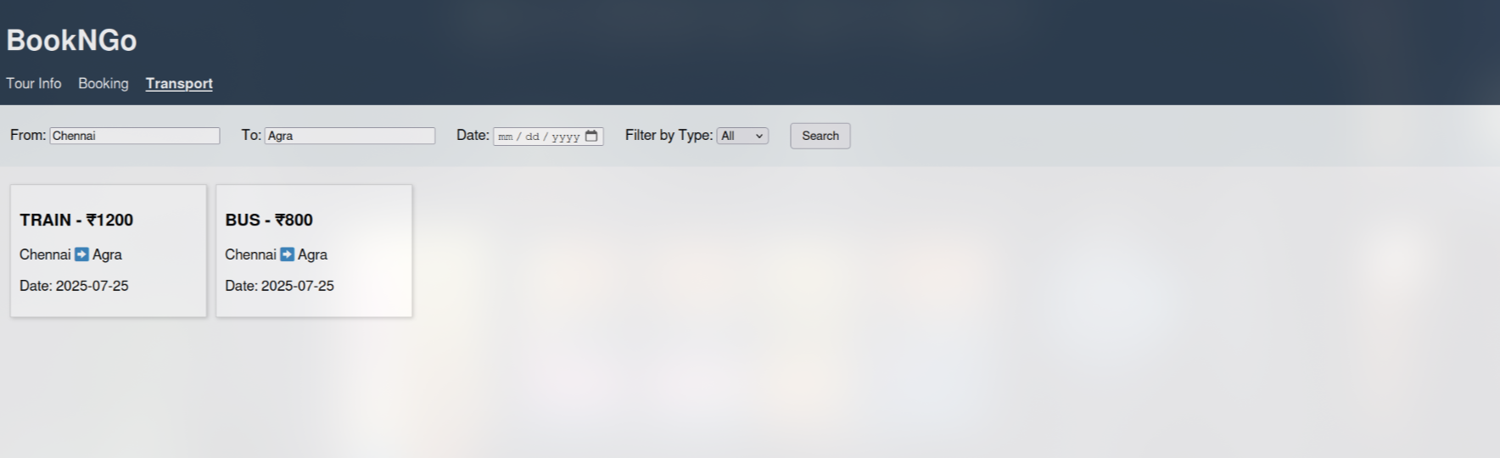

Room Booking:
